**Project Design Phase**

**Solution Architecture**

|  |  |
| --- | --- |
| Date | 28 June 2025 |
| Team ID | LTVIP2025TMID32623 |
| Project Name | Enchanted Wings: Marvels of Butterfly Species |
| Maximum Marks | 4 Marks |

**Solution Architecture:**

Solution architecture is a complex process – with many sub-processes – that bridges the gap between business problems and technology solutions. Its goals are to:

**1. Alignment with Business Objectives**

* **Ensure the solution supports and enables the strategic goals of the business.**
* **Deliver measurable business value and improve business processes.**

**2. Scalability**

* **Design the solution so it can grow smoothly with increasing user demand or data volume.**
* **Allow for easy addition of new features or components without major redesign.**

**3. Performance and Reliability**

* **Provide responsive and reliable service.**
* **Minimize downtime and ensure fast processing times.**

**4. Security**

* **Protect data and services against unauthorized access or breaches.**
* **Ensure compliance with relevant security standards and regulations.**

**Example - Solution Architecture Diagram:**

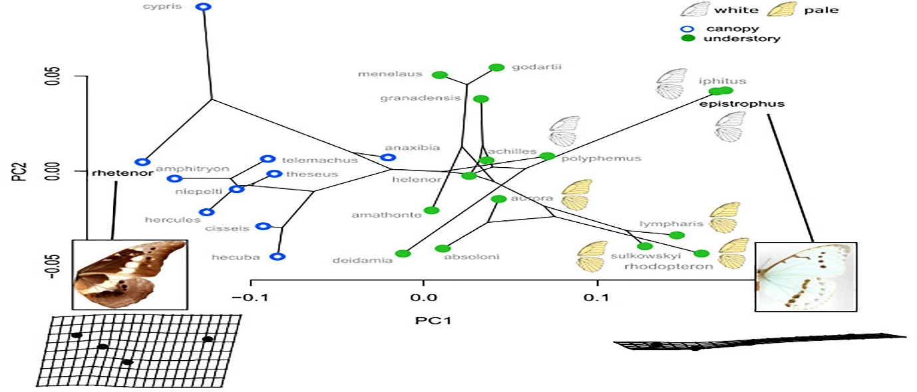

*Figure 1: Architecture diagram of butterfly species*

**Reference:** [**https://aws.amazon.com/blogs/industries/voice-applications-in-clinical-research-powered-by-ai-on-aws-part-1-architecture-and-design-considerations/**](https://aws.amazon.com/blogs/industries/voice-applications-in-clinical-research-powered-by-ai-on-aws-part-1-architecture-and-design-considerations/)